Name_______________________________ Date____________________________________#2

- What is the best estimate to measure the length of a bat?  - 80 km  - 80 mm  - 80 cm  - 80 m | 5. What statement is true?  - 800cm = 8 kg  - 8 m > 80 cm  - 8 m < 800 cm
- What is the best measure for the capacity of a bowl?  - 1 mL  - 1 L  - 100 L | 6. Find the area:  35m  15m  Area = __________________
Find the area:  3.  4$\frac{1}{2}$  4$\frac{1}{2}$  Area = ________________ | 7. Find the area:  76d  Height = 22 cm  Base = 50cm  Area = ______________
4. Fill in the chart  Cubic measure Capacity Of water Mass of water  3mL 3g  9L 9kg | 8. Mary has a strip of ribbon that is 4.5 meters long. How many centimeters is it?
9. Compare < , >, =  45cg ______ 4500mg | 13. What is the volume of a cube that measures 8m on each edge?
10. What is the area of a triangular piece of marble with a height of 10inches and a base of 20 inches? | 14.  8000m = _____kg
11.  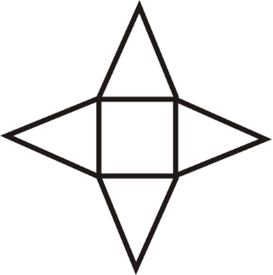  What solid figure does this net represent? | 15.  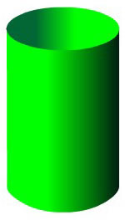  Name the solid figure.
12. What unit would be used to measure the weight of a dog?  - Kilograms  - Kiloliters  - kilometers | 16. What unit would you use to measure the length of a football field?  - Milliliters  - Centimeters  - Meters

