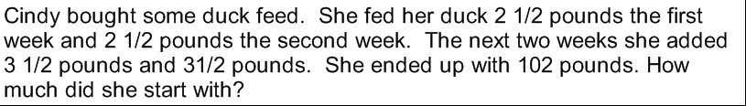

1) 7$\frac{1}{2}$ 2) 4$\frac{5}{6}$ 3) 8$\frac{1}{8}$
-2$\frac{3}{4}$ -1$\frac{1}{8}$ -3$\frac{2}{3}$

4) There are 12$\frac{1}{3}$ yd of material on a bolt. If 3$\frac{3}{4 }$ yd are used, how much material is left on the bolt?

5) 5$\frac{3}{5 }$ + 7$\frac{3}{10}$ + 3$\frac{1}{2}$ = _____

6) Make a front end estimation.
5$\frac{2}{3}$ - 3$\frac{2}{9}$

Find the difference in simplest form
7) $\frac{11}{12}$ 8) $\frac{3}{4}$ - $\frac{3}{10}$ = ____
- $\frac{3}{4}$

9) 5$\frac{2}{3}$ 10) Round
-4$\frac{4}{5}$ 8$\frac{1}{3}$ - 4$\frac{2}{7}$
Answer Key
N - 2$\frac{1}{2 }$ - 2$\frac{1}{2}$ +3$\frac{1}{2}$ +3$\frac{1}{2}$ = 102.
102 + 2$\frac{1}{2 }$ + 2$\frac{1}{2}$ -3$\frac{1}{2}$ -3$\frac{1}{2}$ = N
(102 + 5) -7 =N
107 =N
100 =N

- 4$\frac{3}{4}$ 2) 3$\frac{17}{24}$ 3) 4 $\frac{11}{24}$ 4) 8$\frac{7}{12}$ 5) 15$\frac{2}{5}$

6) 2 7) 1$\frac{1}{3}$ 8) 1$\frac{1}{4}$ 9) 10$\frac{7}{15}$ 10) 4

